The following is *my* method for creating and maintaining a Master List. The only “authority” it has is, it was the first. Half a decade of figuring out how to make it go smoothly suggests that most of this will work well for you – but things change over time. Don’t be afraid to try different methods if they will work better for you.

What is a Master List

If you’ve ever tried to find something in the NYCM forums, you know they’re a little challenging to navigate on an ordinary day. On “contest day” when hundreds of people are posting stories for review, it can be next to impossible to find a post at all, much less make sure you have found all the posts of a specific type (friends, people in your group, etc.) The Master List is designed to be a Table of Contents to the story-posting forum.

The Master List is just a post, with a list of stories and links. Keeping one isn’t hard – though it can be busy work for a week or so.

## A few things to know about maintaining a Master List:

* Because it is just a forum post, all the rules of form posts apply. That means that only one person can edit the list.
* Others can help by posting comments to highlight missed stories, typos or minor errors in the List, and by helping new participants who are having trouble navigating the forum.
* The Master List can disappear as fast as any other post. Ways to keep the Master List at the top of the forum:
  + [adequate]: Constant comments, to bump it to the top of the list
  + [better]: If you’re the keeper of a Master List, e-mail NYCM the week before the first round begins to tell them you’ll be keeping a Master List and would like permission to “sticky” posts in the contest forum. They’ll most likely ask you to remind them once the forum has been created – that’s fine, the purpose of the email is to get on their radar. That way, when the forum is created, you can just forward that message back to them as a reminder. If they’re expecting it, they make the change pretty quickly.

## A few things to keep in mind when maintaining a Master List:

* You’ll want some intro text – new participants won’t know all the stuff that old-timers know, and explaining it gets repetitive.
  + I have a standard set of text I put at the top of *every* list – I just copy it from the pervious list every time. It includes instructions *only* about the Master List itself.
  + It links out to the post “This is for all you new people” in the CWC forum, where folks can find instructions on things like making a post and linking their story.
  + People aren’t going to read it. It’s there so that when they ask silly questions (and when we’re all excited about posting our stories, even the old-timers will ask a few silly questions 😊 ) you can remind them that the info is at the top of the ML. It saves you a lot of typing.
* Keep it simple
  + Forum posts have a maximum character count. (This is why when the contests started growing, we started splitting MLs into two groups – Groups 1-50 & 51-100 for example.) If your post exceeds that, you will not receive a usable error – the post just won’t save when you hit the save button.
  + The ransom note effect (random fonts, sizes, and colors) does not increase the probability that people will read the intro. It *does* make the intro harder to read when people are sent there, and it forces them to scroll further to get to the actual list. This is a place for “simple and utilitarian” – save the artistry for your incredible NYCM competition pieces.

## Nixie’s Standard Master List Text (feel free to steal/edit)

As Always:

**Links go to your FORUM POST, not directly to your story**

* This allows folks to leave feedback
* **If there is no forum post, I can't link it.**
* Please make sure your story's TITLE and chosen prompt GROUP is in the post somewhere

Comment here with a link to your **POST**, to be sure I see it. If you see someone else’s post and they aren’t on the list – give ‘em a hand. Comment here with a link to their post.

Once your story has been added, **please check spelling, links, etc.** My typos are legendary.

"If you see something, say something" - if I knew it was wrong, I'd have fixed it already.

I maintain Master List posts for 30 days or until the next round, whichever comes first. Posts added more than a month after the round will get added "if I see them, if I have the time, and if I notice." ;)

Instructions for making forum posts, links, signatures, etc., can be found [**here**](http://forums.nycmidnight.com/this-is-for-all-you-new-people_topic12975.html).

Step By Step: Making A List

1. Create a new post!
2. Subject: Master List Round #
3. Add your intro text
4. 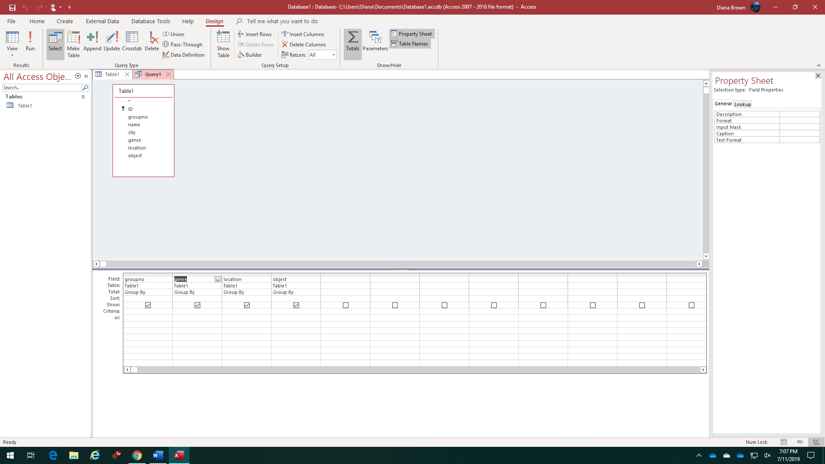Get Your Group Headings  
   There are a few ways to get the group headings. If you have MS Access or another database application, that’s quickest:
   1. Go to the contest Web Page
   2. Select and copy the list of contestants
   3. Paste this list into a new table
   4. Create a query
      1. Add the fields for group number and prompts
      2. Use the grouping feature in your query interface
      3. If your database engine doesn’t have a pretty button for that function, the SQL version of this query looks like this:  
         SELECT Table1.groupno, Table1.genre, Table1.location, Table1.object  
         FROM Table1  
         GROUP BY Table1.groupno, Table1.genre, Table1.location, Table1.object;
   5. The output of this query lists each unique value for “group + genre + location + object” only once. Voilà! You have a list of the groups and prompts
      1. Pro Tip: paste this into a word processor using the “paste as text” option. If your word processor doesn’t have one, look for “paste special” and choose “unformatted text.” This will paste each entry as a line of text, with no tables, grids, or other formatting that may bite you later.
      2. Once it is in your word processor, use the “Find/Replace” function to replace every carriage return [¶] with two carriage returns. Poof! You now have a list of groups + Prompts, with a blank line in between
      3. Extra Credit: Select one line of text, and change its format (bold, underline, color blue, whatever). Then use the format painter to copy that format *only* to the liens of text (the blank lines in between remain black and normal – so when you add list items, the blue/bold headers will stand out)
5. [Ctrl]+[A] to “select all” and paste this into the body of your post.

**If you’re not a database person, you can do this with a bit more grunt work in Excel. Or ask around and make some geek do it for you.**

1. Check the options – you should have a drop-down right next to the subject line that reads “Normal Topic.” Change this to “Sticky Topic” to keep your Master List at the top of the forum.
2. Hit [Save] – you have a Master List!

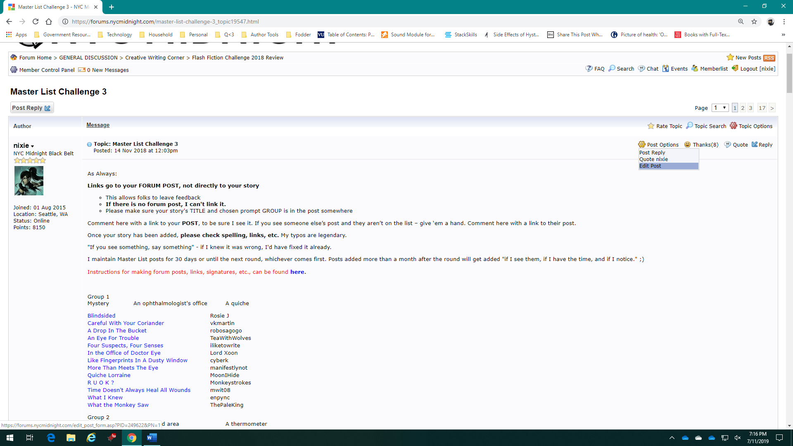Step By Step: Adding a Story to the Master List

First, open your post for editing by clicking **Post Options**, then **Edit** at the top right.

1. Find the right group
2. Add the Story Title
3. Tab over
4. Add the Author’s name
5. Select the Title
6. Add a hyperlink to the story (you can find instructions with screen shots [here](https://dianabrown.net/creating-a-link-in-your-post/).)
7. [Save]

Pro Tips:

* When the server is busy, or you have made lots of updates, your save may fail – and you’ll lost your work. To prevent psychosis, right before you hit “save” – Try [Ctrl]+[A] to select the entire post and then [Ctrl]+[C] to copy. If the save fails, you can [Ctrl]+[A] and then [Ctrl]+[V] to paste – and you’ll have your work back so you can try the save again. When things are really busy, sometimes I paste it into a word document ‘just in case’ - if the server stays cranky for too long, I can save the doc and come back to it later.
* For the first few hours, your tabs/alignment will be messed up. Let it ride. Once you have a few entries in the list, you’ll be able to judge where a good alignment for the author’s name is. Then you can go back and add the requisite number of tabs to the existing entries. (Yes, it *does* matter. A clean line makes the list easier to look at, and easier for the human eye to process. Ragged ‘columns’ make using the list fatiguing for eyes and brain. It doesn’t have to be perfect, but the more effort you make, the easier it will be on everyone.)

Tracking Stories

That’s the mechanics – then, there’s the realities of Game Day. You’ll figure out your own method of managing a list – but here’s mine:

## Forum Posts

I go to the forum posts *first*. I use the comments on the ML post as my backup/verification. This makes sure that I catch newbies who don’t know how to get added to the list or think it’s automatic – and occasionally means I manage to get someone’s story on the list before they have even posted. It’s a tiny thing – but it makes people smile to be noticed and taken care of.

1. Right-click *every* new story and open it in a new tab.
   1. This takes me to the forum post for that story – which makes it easy to get a clean link
   2. This marks the post as one I have read – which means when I come back to the forum later to check for new stories, it will *not* be bold – it will not show as “new”. That’s SO much easier than trying to read the time stamps
2. I open the Master List post and drag that tab into a *separate window*. (alternately, you can just open a separate browser and open the ML there. The point here is to have two windows open)
3. For each story:
   1. I look at the post, to see the group, Title and author’s name
   2. [Alt]+[Tab] to the Master list and type this info in
   3. [Alt]+[Tab] back to the story, and click in the address bar to select and copy the url
   4. [Alt]+[Tab] back to the ML to add the link to the story title
   5. [Alt]+[Tab] to the story window, and close that tab (I use [Ctrl]+[F4] but clicking the x works too)

This method ensures that I know which stories I haven’t added yet. If the window is open, there’s still work to be done!

1. Pro tip: The forum limits the number of saves you can do in a short time period. Don’t try to save every line – enter 5 or 10, and then save. If something goes wrong *and* you forgot to copy first, that’s a small number to track down.

And now, for the comments on the ML post itself

## ML Comments

I handle the story adds first, and the other comments afterward.

1. Again, right-click every link and open in a new tab
   1. If it opens to a forum post, add to list, of course
   2. If it opens to something else – leave it, for now.
2. Once the stories are added, Save the list
3. Comment on the list – anything! “Gotcha!” “Caught up through this point.” Those aren’t just nice acknowledgments to the other writers – that comment tells you where you left off in the list. When you come back in the morning, you can scroll up to your own last comment, and start from there.
4. Answer questions, click “thank” to folks who thanked you (more than a nice gesture, this raises their forum participation score – making them more visible is a nice way to acknowledge them)
5. For the folks who linked their stories directly instead of linking a forum post, I keep a template message that I PM them with. Alternately, if you see an existing old-timer already commenting – they may already have the person squared away. 😊
   1. It’s important that you stick meticulously to the rule of only linking forum posts. Both from a “you don’t want to manage that nightmare” point of view, and from the “making sure everything stays in-house” point of view. Remember that how people post and share can be the difference between their material being considered “published” or not by many markets. This is a great part of the process to not change just for experimentation’s sake 😊
   2. That message to the person who linked the wrong thing:

Hi [writer]!

Looks like you accidentally put the link to your story in the Master List comments, instead of to your forum post. For the List, we always link to the post – that way other writers know where to leave you feedback! Can you drop me a link to your post – either here, or just add a new comment to the Master List? – so I can get you added and let folks know where to find you?

p.s. if you’re having trouble with the post, there’s a guide on how to do it – it’s linked at the top of the master list. Just click the link and read through, and if you have any trouble don’t hesitate to message me, or post in the CWC forum – folks here are really helpful and supportive!

* 1. Be kind. People who haven’t done it right already feel silly – and if they are not comfortable with technology, may be feeling stupid, or not know how to do it “right.” Don’t make it worse. If you don’t have time to help them – consider reaching out to one of the old hands who is active and asking them to touch base with Newbie to give them an assist.

Step By Step: The Master List (Summary)

1. Create a post
   1. Subject: Master List Round #
   2. Make it sticky
   3. Paste in a list of your groups/prompts
2. Edit post
   1. Add title and author
   2. Add link
   3. Copy before saving, just in case.
3. Manage new entries
   1. Open in a browser tab to mark them as read
      1. when you come back, only the new ones will be bold/unread)
   2. Close the tabs as the info is added to the list
      1. Open tabs = new items to add
   3. Comment on the master list to bookmark the spot where you left off
   4. Let the folks who screwed up know – so they can get you the right info (or so that you can get them some help if they are flailing)
4. For all these things, try to keep it neat and pretty
5. Say thank you
   1. My practice is to “thank” anyone who thanks me or leaves a kind comment
   2. I don’t do that for folks who just post their link. What I do for them is ‘add them to this handy master list” 😊 Someone who goes to the extra effort to be kind to me, gets a kindness in return.
   3. Your practice may be different. I’m kind of cranky and not very nice. You’re probably a lot nicer than that.